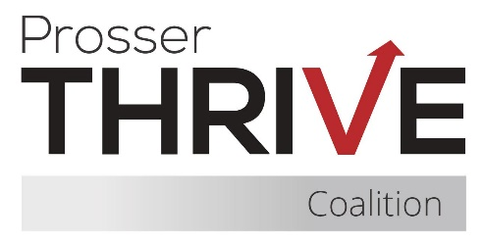

Call to order
A meeting of Prosser Thrive Coalition was held at Thrive Youth Cafe on February 17, 2026, at 8:15 am, with a hybrid option via Zoom.

Attendees
Brittany Augilar, Briseida Chavez, Chris Cisneros (zoom), Genesis Cosina, Derek Dragseth (zoom), Jenny Colgan, Erika Alvarez (Zoom), Jani Andrews, Heather Morse, Eloisa Ramirez, Koleen Schlenker, Miranda, Michelle, Anna Ramirez, Tereka Bojanowski, Yahaira Lemus (zoom) and Miranda Sahagun (zoom).

Attendance & Member Updates
- Chris Cisneros: Recognized Student of the Year at the Boy and Girls Club.

- Makayla: Shared updates from the café, including ongoing student engagement through daily activities. Announced an upcoming movie night scheduled from 3:30 PM to 5:30 PM.

- Yahaira Lemus: Reported that Youth Summit registration is now open. Also shared that Sticker Shock has funding available to complete assessments.

- Miranda Sahagun: Provided updates on data collection efforts and the Youth Panel. Encouraged members to complete the interest form to be included on the list by September 15, 2026. Also discussed involvement in the Mental Health Rural County Project.

- Derek Dragseth: No updates provided.

- Michelle: Reported no updates from Prosser School District.

- Jennie Colgan: Shared progress on securing a bus for the Youth Summit. Also mentioned an upcoming leadership meeting related to National Drug initiatives.

- Laura Hermosillo: No updates.

- Genesis Cosina: No updates.

- Anna Ramirez: No updates.

- Eloisa Ramirez: Announced plans for Violence Awareness Month, with a focus on programming and outreach for teens.

- Tereka Bojanowski: No updates provided.

- Koleen Schlenker: No updates.

- Heather Morse: Reported that positions have been filled at Grandview Memorial Hospital.

- Brittany Aguilar: Updates will be discussed further into our meeting.

Approval of Previous Minutes

Previous meeting minutes were reviewed, including discussion on:

- Fundraising efforts
- Winter Ball

A motion was made to approve the minutes. The motion was made by Jennie Colgan and seconded by Tereka Bojanowski.

Current Business
- Treasurer’s report
  - CPWI: $ 8068.37 (December) Salary benefits
  - YCCTPP: $6163.87 Salaries, benefits, rent, utilities, subscriptions, weekly activities

Coalition/Committee Updates
- Recent Events
- Fundraising, sip and paint
- Winter ball
- Upcoming Events
Members were encouraged to join and participate in the following subcommittees:
  - Montana institute is coming up virtually and in person
  - After Prom
  - Key leader
  - IY
  - Subcommittees
- PCN
- Mental Health awareness (May 2026)

Fundraising Updates

Raffle Fundraiser:

- A handful of community members have already contributed gift cards.

- Continued participation and donations are encouraged.

Additional Discussion

A Vape Prevention Video was discussed as part of ongoing prevention and awareness efforts.

Final Items & Meeting Close
Next meeting March 19, 2026 @ 8:15am
Meeting adjourned 9:30 am
_____________________________________
Heather Morse, Chair

Attest:

____________________________________
Laura Hermosillo, Secretary

