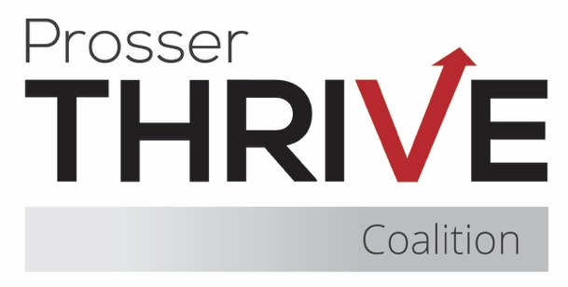

Prosser Thrive Coalition Meeting Agenda
October 20, 2025 ♦ Thrive Youth Cafe or Zoom ♦ 6:00pm – 7:15pm

6:00 – 6:20 Business
- Nominations and Voting
  - Chair
  - Treasurer
  - Member at Large
- Introductions & Community Partner Updates
- Treasurer Report
- Approval of Minutes
- Membership Agreements

6:20 – 6:25 Coalition Assessment Tool

6:25 – 6:30 Coalition Updates & Planning
- Mustang Thrive (standing item)
- Thrive Youth Café (standing item)
- Upcoming Trainings
  - HIDTA Prevention Summit – 10/29
  - Quit Coach Training – 11/7
  - Prevention Ethics - November 12, 13, 19, 20
- Recent Events
  - Touch-a-Truck
- Upcoming Events
  - Red Ribbon Week – 10/23-31
  - Monster Ball – 10/25
  - Downtown Trunk or Treat – 10/31
  - Mural Reveal – 11/14

6:30 – 7:15 Scroll, Swipe, & Substances — What Parents Need to Know– Shelby Jensen

7:15 Final Items & Meeting Close
- Next Meeting – November 20th @ 8:15am

