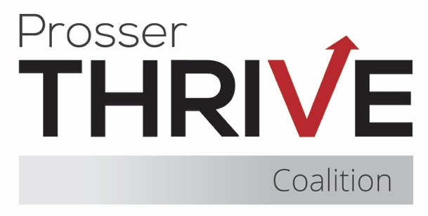

Prosser Thrive Coalition Meeting Agenda
November 20, 2025 ♦ Thrive Youth Cafe or Zoom ♦ 8:15am – 9:30am

8:15 – 8:35 Business
- Introductions & Community Partner Updates
- Treasurer Report
- Approval of Minutes
- Membership Agreements

8:35 – 8:45 By-Laws

8:45 – 9:05 Coalition Updates & Planning
- Mustang Thrive (standing item)
- Thrive Youth Café (standing item)
- Recent Events
  - Red Ribbon Week
  - Monster Ball
  - Downtown Trunk or Treat
  - Mural Reveal
- Upcoming Events
  - None!

9:05 – 9:25 Fiscal Updates
- CPWI
- YCCTPP
- 3 Rivers

9:30 Final Items & Meeting Close
- Next Meeting – December 18th @ 8:15am

