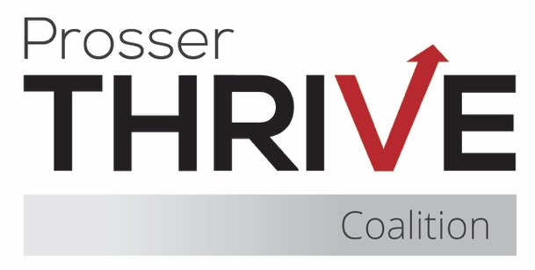

Prosser Thrive Coalition Meeting Agenda
December 18, 2025 ♦ Thrive Youth Cafe or Zoom ♦ 8:15am – 9:30am

8:15 – 8:35 Business
- Introductions & Community Partner Updates
- Treasurer Report
- Approval of Minutes
- Membership Agreements

8:35 By-Laws

8:35 – 9:25 Coalition Updates & Planning
- Mustang Thrive (standing item)
- Thrive Youth Café (standing item)
- Upcoming Trainings
  - Prevention Basics - Tuesdays, January 13, 20, 27, February 10, 17, 24, March 3, 10, 2026 from 1:00 - 2:30 pm (PTTC)

Uncovering What Does NOT Work in Substance Misuse Prevention - Jan. 7, 2026 10:00 am (PTTC)
  - Youth Mental Health First Aid – January 21, 2026 (ESD123)
- Fundraising Planning
  - Winery Partnerships
    - Salsa Night
    - DJ Night
  - Mom and Daughter Sip and Paint w/Coffee
  - Dad and Son Quarter Zip and Matcha
  - Winter Ball After Party
    - Event Planning Subcommittee
  - Concessions
  - Eagles
  - Key Leader Match Funds
  - 50/50 at Coalition Meetings
  - Raffle
    - Donations due 1/22
    - Ticket sales due – 2/19
    - Virtual raffle – 2/28

9:25 – 9:30 Final Items & Meeting Close
- Next Meeting – TBD

