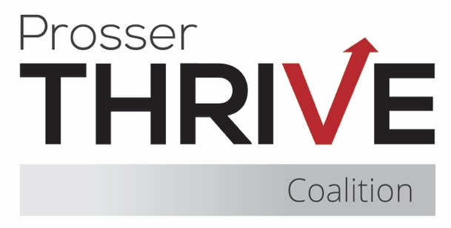

Prosser Thrive Coalition Meeting Agenda
April 17, 2026 ♦ Thrive Youth Cafe or Zoom ♦ 8:15 – 9:30am

8:15 – 8:35 Business
- Sign-in
- Secretary Nominations and Voting
- Introductions & Community Partner Updates
- Approval of Minutes
- Treasurer Report

8:35 – 8:50 Coalition updates & planning
- Trainings

Preventing Underage Substance Use and Supporting Self-Care Through Social Media – April 21 @ 11am
  - Uncovering What Does NOT Work in Substance Use Prevention – April 22 @ 2pm

Not Just the Future—The Now: Youth Driving Change in Prevention – April 28 @ 2pm
- Mustang Thrive
- Youth Café
- Problem Gaming and Gambling Grant
- Recent Events
  - Regional Youth Summit
  - National Drug and Alcohol Facts Week
  - Candle Lab
- Upcoming Events
  - The Incredible Years - Grandview
  - Take Back Day
  - After Prom – Volunteers Needed
  - Spring Youth Forum
  - Mental Health Awareness Month

8:50 – 9:20 Krista Timm – Legislative Recap

9:20 – 9:25 Community Survey & Subcommittee Sign-Ups

9:25 – 9:30 Final Items & Meeting Close
- Next Meeting – May 21 @ 8:15am

