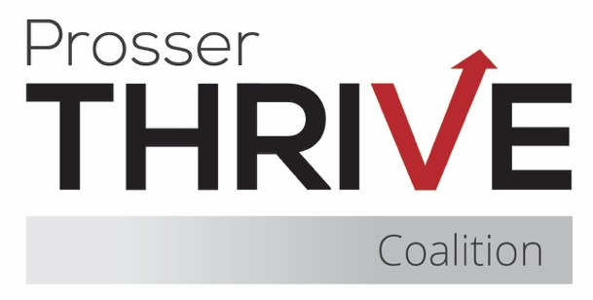

Prosser Thrive Coalition Meeting Agenda
September 18, 2025 ♦ Thrive Youth Cafe or Zoom ♦ 8:15am – 9:30am

8:15 – 8:45 Business
- Introductions & Community Partner Updates
- Treasurer Report
- Approval of Minutes
- Membership Agreements

8:45 – 9:00 Coalition updates & planning
- Mustang Thrive (standing item)
- Thrive Youth Café (standing item)
- Grant Updates
  - CPWI
  - YCCTPP
  - DFC
- Recent Events
  - Yard Sale
  - State’s Day Parade
- Upcoming Trainings
  - Kratom and Other Novel Drugs
    - 9/22 10am
  - Youth Tobacco Prevention – Alternatives to Suspension
    - 9/25 11am-12pm
  - Is the rise in cannabis-induced psychosis unstoppable?
    - 9/29 7am
  - Youth Mental Health First Aid
    - 10/23 8am
- Upcoming Events
  - Red Ribbon Week – 10/23-31
  - Monster Ball – 10/25
  - Downtown Trunk or Treat – 10/31
- Subcommittees
  - Event Planning
  - Data
  - Sustainability and Fundraising
  - Mental Health Awareness
  - Youth Cafe
- Upcoming Elections
  - Chair
  - Treasurer
  - Member at Large

9:00 – 9:05 CADCA Shareout – Erika

9:05 – 9:10 The Montana Institute Shareout – Jennie

9:10 – 9:25 CPWI Strategic Plan

9:25 – 9:30 Final Items & Meeting Close
- Next Meeting – October 20th @ 6pm

